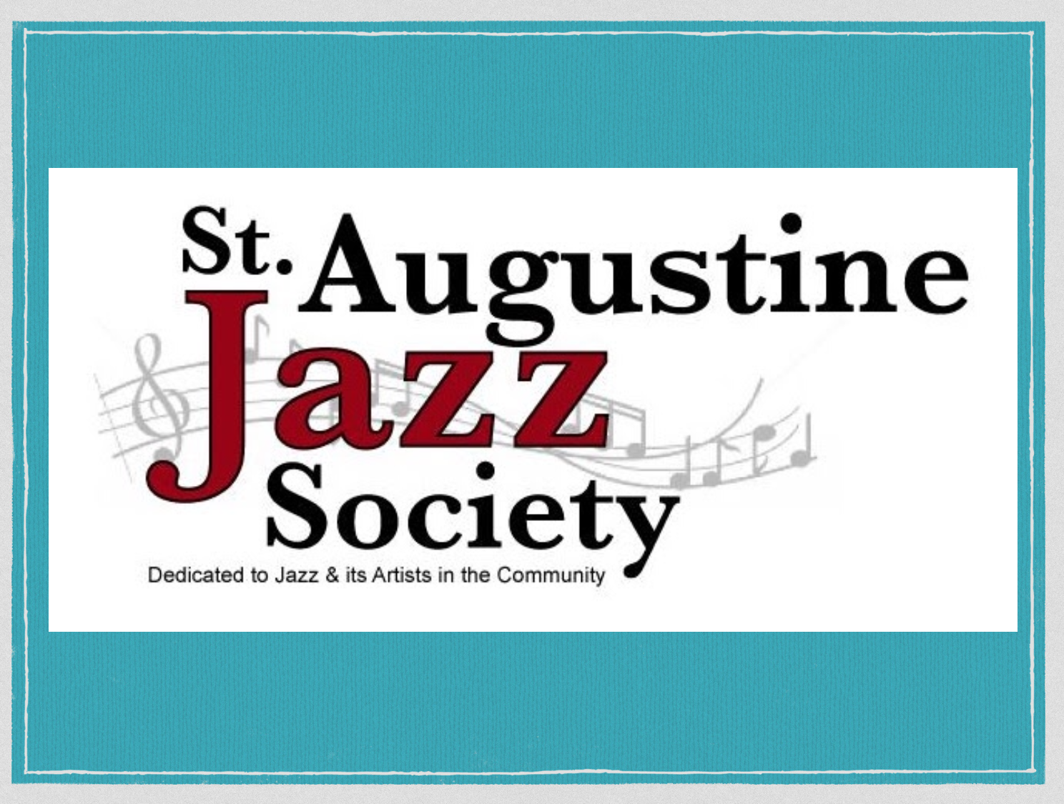

New Instrumentalist and Vocalist Bio Application
YOUTH

Name: ___________________________________________________________________
Grade: ________ Age: ________
Check the following that apply:
- Instrumentalist
- Vocalist
Instrument(s) (if instrumentalist): ____________________________________________________________________________________________________________________________________________________________________________
School: ______________________________________________________________________________
Band Director: _______________________________________________________________________
Years as a musician: _________________________________________________________________
Favorite Jazz Genre: _________________________________________________________________
Jazz Idol(s): ____________________________________________________________________________________________________________________________________________________________________________
What ensembles are you currently a part of? ____________________________________________________________________________________________________________________________________________________________________________
What are your largest/most notable performances? ____________________________________________________________________________________________________________________________________________________________________________
Goals (in education, music, and life): ____________________________________________________________________________________________________________________________________________________________________________
To be published on our website, a parent/legal guardian MUST sign:
Signature: _________________________________________ Date: ____/____/________

